God created every individual member of the body of Christ (i.e. the local church) with unique strengths and abilities, placing them together as a team in order to build His Kingdom. Ministry Insights’ Leading From Your Strengths is an online assessment that empowers Christian leaders and team members to discover their God-given strengths and to discern where and how they fit in a specific team context. The LFYS Profile provides a 20+ page picture of your individual make-up, with over 19,860 unique strengths combinations. The assessment takes approximately ten minutes to complete, with results delivered instantly and interpreted fully.
If the whole body were an eye, where would be the sense of hearing? If the whole body were an ear, where would be the sense of smell? – 1 Corinthians 12:17

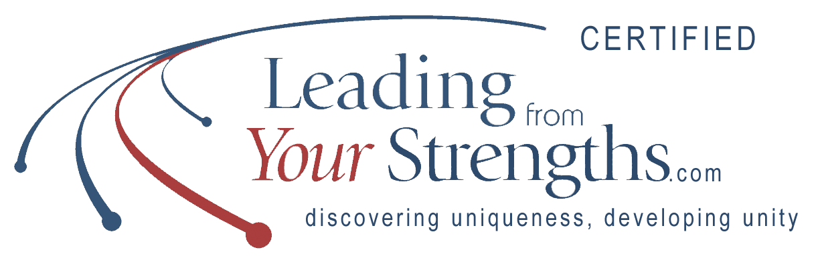

For more information, please contact Vesta Clary at vclary@mbcb.org or 601-292-3310 at MBCB’s Strategy Office to schedule a consultation with a certified specialist.

