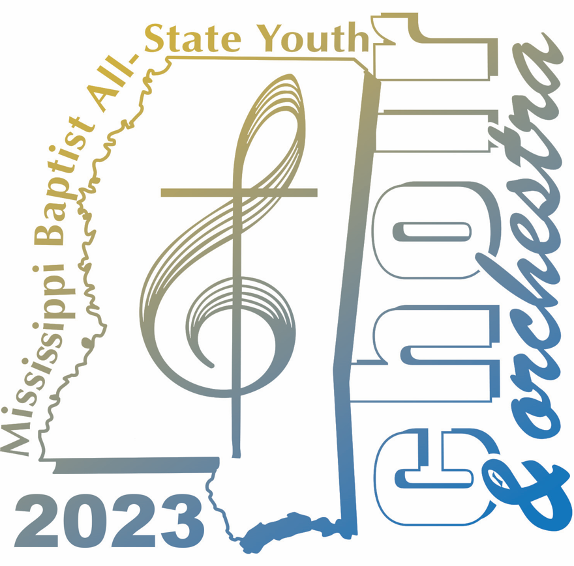 | INFORMATION PACKET  Worship Ministries  For more information, call  601-292-3267  It is very important that you read all of this  information carefully and respond on time. It would  also be helpful for your parents to read this.
=============================================================================
1. Dates: June 12-19 Rehearsal Camp: June 12-14
William Carey University Campus
Hattiesburg, MS

Tour: June 14-19
Wednesday, June 14 – Hardy Street Baptist Church– Hattiesburg – 6:00 p.m.
Thursday, June 15 – Tylertown Baptist Church – Tylertown – 6:00 p.m.
Friday, June 16 – First Baptist Church – Gulfport – 6:00 p.m.
Saturday, June 17 – First Baptist Church – Laurel – 6:00 p.m.
Sunday, June 18 AM – First Baptist Church – Magee - 10:00 a.m.
Sunday, June 18 PM – First Baptist Church – West Point – 6:00 p.m.
Monday, June 19 – First Baptist Church, Jackson – 6:30 p.m.

====================================================================================

2. Registration: June 12 Check in at Thomas Fine Arts Building
Participants will be given a “Check-In Process” card upon arrival at WCU
to direct them through the steps of checking-in.
9:00-9:30 a.m. – All Instrumentalists
10:00-11:30 a.m. – All other choir members
Lunch will be served in Wilkes Dining Hall for students only.
After checking in, choir members must stay on campus.

====================================================================================

3. Full Instrumental Rehearsal 10:15 a.m. – All instrumentalists must attend.
Auditorium Stage – Thomas Fine Arts Building

====================================================================================

4. Auditions Vocal and Keyboard Concert Features
Beginning at 10:00 a.m. in the Thomas Fine Arts Building
Only people with prepared pieces may audition for concert features.
You must audition using the musical selection you plan to perform.
No accompaniment tracks are allowed for concert features or talent show.
Please note: Only one audition time is scheduled.
Talent Show: Talent show auditions for rehearsal camp will also be at
this time.

====================================================================================

5. Orientation: June 12 1:00 p.m. – Mandatory meeting for all participants (no exceptions)
Choir Room on second floor of Thomas Fine Arts Building

====================================================================================

6. Instruments If you auditioned and were selected to play in the orchestra, bring your
band instrument. The orchestra will prepare preludes and concert features.

Guitarists, please note: Unless you have been selected to play guitar
In the orchestra, please do not bring your personal guitar. There is
very limited luggage space on the buses. There will be quality guitars
available for you to use. Please see Billy Knight to make arrangements
for borrowing a guitar once you get to rehearsal camp.

====================================================================================

7. Transportation Participants are responsible for transportation to WCU and for their
return home following the home concert at FBC, Jackson.
Choir members may not bring personal vehicles to the WCU campus.

Transportation while on tour will be chartered, commercial motor coaches. Eating and drinking will be allowed on these vehicles, but it is your responsibility to make sure that all trash is disposed of properly. There will be trash bags placed throughout the vehicles for your convenience. If the buses become “trashed,” the food/drink privilege will be taken away.

====================================================================================

8. Lodging Dormitories at William Carey University, June 12-14
Mississippi Baptist All-State Youth Choir & Orchestra
WCU, Student’s Name
498 Tuscan Avenue
Hattiesburg, MS 39401

Housing while on tour will be arranged by the host church.

Participants must remain with the group throughout the rehearsal camp and tour. We will respect the
housing arrangements made through the host churches. No exceptions will be made. If a choir
member plans to stay with a relative or family friend at any of our concert locations, these plans must
be indicated on the enclosed response sheet and must be approved by a parent’s signature. This
information must be received by Elizabeth Knight (elizabeth_knight@ymail.com) no later than Friday, April 28.

====================================================================================

9. Room Assignments Made by the Worship Ministries Department
Indicate your roommate preference on the enclosed response sheet
and return it to Elizabeth Knight (elizabeth_knight@ymail.com) no
later than Friday, April 28. Persons wanting to room together MUST be sure to list each other. Check with the person with whom you plan to room before writing their name on the form.

10. Sponsors and Leadership are enlisted and provided by the Worship Ministries Department

Choral Director Slater Murphy
Instrumental Director Byron Green
Instrumental Director Assistant Michelle Green
Accompanist Brian Murphy
Camp Pastor Sam Ivy
MBASYC&O Event Coordinator Elizabeth Knight
Counselors Kenny Adams, Mark Davis, Matthew Gaddy, Billy Knight,
Turner Luttrell, Jr., Lora Beth Pannell, Marsha Murphy
Jennifer Nanney, Anthony Turner, Judy Turner, Jason Walker, Leslie Williams
Medical Staff Caleb Jay, Alex Papania

====================================================================================

11. Camp, Tour and Concert Dress Guidelines
All youth participating in the 2023 MBASYC&O must comply with the dress code outlined in the first
packet received.

Rehearsal Camp (3 days)
- Modest, conservative clothing is appropriate at all times
- Shorts – no shorter than your fingertips (arms fully extended, while standing)
No gym shorts or athletic shorts
- No tank tops, spandex shorts, transparent clothing for boys or girls
- No bare midriffs
- No spaghetti straps or sleeveless shirts
- Sweater or jacket for air-conditioned buses and buildings
Tour Travel Clothes
- Nice pair of blue jeans and casual shoes/sandals (no flip-flops) to wear with designated MBASYC&O t-shirt for possible ministry opportunities
- Shorts/pants to wear with designated MBASYC&O t-shirts during travel (5 days)
Concert Dress
- Boys
  - Designated choir attire (shirt and slacks)
  - Black dress shoes (no suede, Nubuck or Wallabee styes; black uppers and lowers)
  - Black socks
- Girls
  - Designated choir attire (shirt and dress pants)
  - Dress shoes (black pumps or flats [hint, flats are more comfortable] – no sandals – closed heel and toe)

- Everyone
  - Neat and trimmed hair (above the eyebrows and out of the eyes) – This is not negotiable and will be checked at registration. Students must comply with these guidelines before registration can be completed.
  - No jewelry (including watches, rings, earrings) during concerts
  - No visible tattoos or body piercing at any time
  - Girls may wear one earring in each earlobe during rehearsal camp and travel time.
====================================================================================
12. Luggage
- To be taken on tour
  - Suitcase Weight: No more than 45 pounds
  - Suitcase Size: Linear measurement of 45 inches (height+width+depth)
  - Carry-on bags shall be small enough to place under your seat (no larger than 16”x5”x12”). A school backpack may be substituted for the carry-on bag.
  - Light weight zippered garment bag
To ensure compliance with these guidelines, bags will be checked at William Carey University as part of the check-in process.
Luggage tags will be issued upon arrival at WCU. Only bags with official MBASYC&O luggage tags will be placed on the bus.
====================================================================================
13. Dirty Linens/Camp Clothes You will be provided a heavy-duty plastic bag to place your dirty
linens and camp clothes in at the close of rehearsal camp.
Provisions will be made to have these bags delivered to FBC Jackson on Monday, June 19 (final concert). Your bag will be available for you to pick up following the concert. You may bring a separate bag with your name on it for this purpose if you desire.

====================================================================================

14. Cost $495
Includes $100 deposit already paid and all your expenses while at rehearsal camp and on tour with the exception of no more than seven (7) meals on tour, snacks, and souvenirs. These expenses will be covered: meals and lodging at WCU, transportation on three motor coaches, two MBASYC&O t-shirts, and insurance.

====================================================================================

15. Emergency Cell Phone Numbers Elizabeth Knight 601-331-2255

====================================================================================

16 Medical Insurance Information You should have received your Medical Release information in an
earlier packet. Please follow the instructions carefully concerning
the medical forms. Remember -- Attach a photocopy of the front
and back of your health insurance cards to the notarized
medical form.

====================================================================================

17. Time is Important We have many times in our schedule when we must meet at a
specific time. Everyone must have a watch or some way to check
the time. Be prepared to always be on time.

====================================================================================

18. T-Shirts Each person will be provided with two MBASYC&O t-shirts
to be worn on alternate days while on tour. In the event of a lost or damaged shirt, replacement shirts may be purchased for $20 each.
Please do not wear your official All-State t-shirts until we are
on tour. Your tour book will indicate which color to wear each day.

====================================================================================

19. Nutrition & Hydration Each student is responsible for maintaining healthy nutrition,
hydration, and rest habits. Our ministry and concert schedule is
very busy, and it is important to eat well-balanced meals three
times a day, being sure to have protein at each meal. Drink plenty
of water. On tour, breakfast is provided in host homes. Lunch will
either be provided by a host church or purchased as we travel.
Evening meals will be provided by the host churches. Bottled
water is always available at rehearsal camp and on the motor
coaches while on tour. Students are encouraged to bring their
favorite nutritional snacks.

Be good stewards by eating, drinking and resting!

====================================================================================

20. Cell Phones and Electronic Devices
Personal cell phones are welcome and useful
instruments for maintaining contact with family and friends and
for emergency communications.

Cell phones should be turned off during worship services, concerts, family group meetings, rehearsals, all organized group activities, and while visiting with hosts in their homes. Cell phones shall not be used after “lights out” in the dorms.

Cell phones will not be allowed on the stage during concerts and will be collected by alumni counselors before performances. You may retrieve them from the alumni counselors after the concert has concluded.

Cell phones and other devices (used with earphones) used inappropriately may be collected by an adult leader and then returned following the session in which they have been misused.

====================================================================================

21. Bed Time/”Lights Out” During rehearsal camp the times listed in your tour book as “lights
out” are not a suggestion. It is extremely important that these times are honored. In order for you to remain healthy and be at your very best, a good night’s rest is essential. Your cooperation with this is important and expected.

====================================================================================

22. Packing List Pack lightly. If your suitcase is too heavy for you to carry, it is
too heavy. Often one must be able to carry luggage up stairs.
- MBASYC&O Music
- Bible, pen/pencil
- Single bed sheets (extra long) or sleeping bag (WCU)*
- Pillow with pillowcase*
- Blanket (optional, the rooms are often cool at night)*
- Towels and washcloths for three days*

- Three sets of casual clothes for rehearsal camp (3 days)
  - Shorts as long as your fingertips when standing
  - Tops that cover the top of your pants when hands are raised over your head
- Sweater or lightweight jacket and umbrella
- Shorts/pants to wear with MBASYC&O t-shirts during travel (5 days)
- Personal toiletry items
- Alarm to wake you up!
- Concert attire
- Nice pair of blue jeans for casual concert/ministry opportunities
- Modest sleep clothes
- Money for no more than seven (7) meals, snacks, etc.
*Bed linens and towels for rehearsal camp may be packed in a separate bag, labeled with your name. This bag will not have an official MBASYC&O luggage tag. This bag will be loaded on a specified vehicle Thursday morning to be transported to the final concert in Jackson. You will be provided a heavy-duty trash bag to put these items in if you do not bring your own personal bag.
You will not need:
- Inappropriate music, CD’s, movies, books
- Alcoholic beverages
- Drugs or tobacco products including vaping products
- Weapons of any kind
- A personal vehicle

