*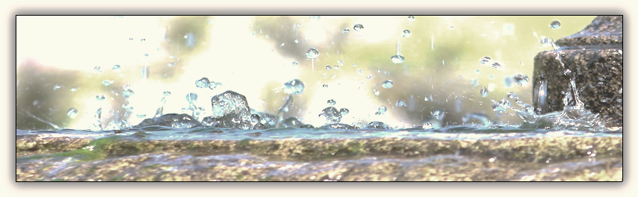Conferencia de Mujeres y Jovencitas*

*Sanidad Interior*

**“La mujer le dijo: Señor, dame esa agua, para que no tenga yo sed, ni venga aquí a sacarla”.**

**Juan 4:15 VRV 1960**

**HOJA DE REGISTRO**

**Envie esta hoja de registro y su cheque a la direcion: Multicultural Ministries P.O. Box 530 Jackson, MS**

**Haga su cheque con pago a: MBCM (Mississippi Baptist Convention Board)**

**Fecha límite para registrarse: Lunes 31 de julio del 2023**

NOMBRE: _________________________________________________________________________________

DIRECCION: ________________________________________________________________________________

CIUDAD: ____________________________ ESTADO: ___________ CODIGO POSTAL: ________________

TELEFONO: _________________________ CORREO ELECTRONICO: __________________________________

IGLESIA: ___________________________________________________________________________________

|  |
| --- |
| **COSTOS:**   * **Adultos $ 45.00** * **Niños de 0-7 años- gratis** * **Niños de 8-12 años $ 22.50** |

|  |  |
| --- | --- |
| **ACTIVIDADES:**   * Cena * Fogata * Manualidades * Tiempo libre * Tiempo de oración * Volleyball-jovenes * Libreria | HORARIO  VIERNES 11 DE AGOSTO  4:00 Llegada  5:30 Cena  7:00 Sesion 1  8:30 Fogata  SABADO 12 DE AGOSTO  8:00 Desayuno  9:00 Sesion 2  12:00 Almuerzo  1:00 Session 3  2:30 Despedida |

**HOJA DE REGISTRO**

Nombre de la Iglesia: _____________________________________________________________________________

Lider: __________________________________________________________________________________________

|  |  |  |
| --- | --- | --- |
| **A D U L T O S** | | |
| **#** | **N O M B R E** | **T E L E F O N O** |
|  |  |  |
|  |  |  |
|  |  |  |
|  |  |  |
|  |  |  |
|  |  |  |
|  |  |  |
|  |  |  |
|  |  |  |
|  |  |  |
|  |  |  |
|  |  |  |
|  |  |  |
|  |  |  |
|  |  |  |
|  |  |  |
|  |  |  |
|  |  |  |
|  |  |  |
|  |  |  |
|  |  |  |
|  |  |  |
|  |  |  |
|  |  |  |
|  |  |  |
|  |  |  |
|  |  |  |
|  |  |  |
|  |  |  |
|  |  |  |
|  |  |  |
|  |  |  |
|  |  |  |
|  |  |  |
|  |  |  |
|  |  |  |
|  |  |  |
|  |  |  |
|  |  |  |
|  |  |  |
|  |  |  |
|  |  |  |
|  |  |  |
|  |  |  |

**HOJA DE REGISTRO**

Nombre de la Iglesia: _____________________________________________________________________________

Lider: __________________________________________________________________________________________

|  |  |
| --- | --- |
| **N I Ñ O S 0 - 7 A Ñ O S** | |
| # | **N O M B R E** |
|  |  |
|  |  |
|  |  |
|  |  |
|  |  |
|  |  |
|  |  |
|  |  |
|  |  |
|  |  |
|  |  |
|  |  |
|  |  |
|  |  |
|  |  |
|  |  |
|  |  |
|  |  |
|  |  |

|  |  |
| --- | --- |
| **N I Ñ O S 8 – 12 A Ñ O S** | |
| # | **N O M B R E** |
|  |  |
|  |  |
|  |  |
|  |  |
|  |  |
|  |  |
|  |  |
|  |  |
|  |  |
|  |  |
|  |  |
|  |  |
|  |  |
|  |  |
|  |  |
|  |  |
|  |  |
|  |  |
|  |  |