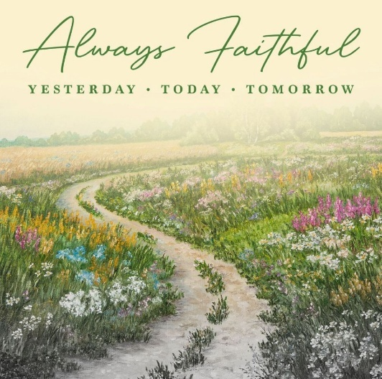
We’re looking forward to seeing you at the
2025 Ministry Assistants Conference and Training!
Please read through this document for details pertaining to the conference.
If you have any questions, please contact Elizabeth at elindigrin@mbcb.org or 601-292-3305.
Beginning Sunday, March 16th, you may contact Elizabeth on her cell phone: 601-842-4501.

Monday, March 17, 2025, 8:00 a.m. - Tuesday, March 18, 2025, 11:45 a.m.

Location
Garaywa Camp and Conference Center, Clinton, MS
Directions: https://garaywa.org/directions/

Lodging
Lodging is available at Garaywa Camp & Conference Center at the rate of $65.00 per night per person. Reservations can be made for Sunday and/or Monday night. When you register, you will have the opportunity to indicate if you are willing to have a roommate and give their name. Every effort will be made to accommodate roommate preferences.

Meals
Monday
Complimentary Continental breakfast
Lunch - $9.00
Dinner - $10.00
Tuesday
Continental Breakfast - $5.00
Conference Schedule

Monday, March 17, 2025
8:00 Registration & Complimentary Continental Breakfast
9:00 Conference begins
9:45 Worship
11:00 Ministry in Times of Crisis
12:00 Lunch
1:00 Q&A Session
(Church Ministry Assistants/Associational Ministry Assistants)
2:30 Break
2:45 Breakout Session #1
3:45 Break
4:00 Breakout Session #2
5:00 MBMAA Business Meeting
6:00 Supper
6:45 Join us for a fun-filled night with a special surprise guest and lots of fellowship!

Tuesday, March 18, 2025
7:30 Breakfast
8:30 Training Session – Social Media Strategies for Churches (part 1)
9:45 Break
10:00 Training Session - Social Media Strategies for Churches (part 2)
11:30 Closing remarks
11:45 Dismiss

Breakout Session Choices:
- Maintaining Church Membership Rolls
- Unlocking Volunteer Potential in Your Church
- Events – Hints and Helps
- Verse Mapping

Conference Speakers

Worship Speaker – Dori Rushing
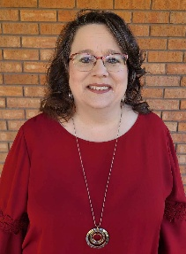
Dori is blessed to be a child of the King, pastor’s wife, momma, and newly, a Nonnie. She has faithfully served alongside her husband in both youth and pastoral ministry for over 20 years. She is a gifted teacher and has a strong desire to disciple others to make disciples and carry out the Great Commission of Christ Jesus. She presently serves alongside her husband at Puckett Baptist Church.

Worship Leaders – Kris Smith & Wyndy South

Kris Smith is the Director of Worship Ministries for the Mississippi Baptist Convention Board, where he provides leadership and support to churches across the state in the area of music and worship. Before joining the convention staff, Kris served churches in Louisiana and Mississippi, including 17 years as the Pastor of Worship & Administration at Carterville Baptist Church in Petal, Mississippi.
Kris and his wife, Hope, are the proud parents of three children, ages 14, 10, and 5. Passionate about leading authentic worship, Kris invests in discipling children, students, and adults to embrace their roles as worshippers and worship leaders in the church.
In his free time, Kris enjoys traveling to Disney Parks with his family, listening to podcasts and audiobooks, and exploring great food.

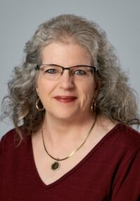
Beginning March 16, 2001, Wyndy joined the Church Music Department, now Worship Ministries team, at the Mississippi Baptist Convention Board. Her responsibilities include leading as Director and Coordinator of the 10 Statewide Keyboard Festivals, planning, coordinating and providing leadership for the Mississippi Baptist Young Musicians Honor choir as well as accompanying many events, festivals, conferences, chapels and the Mississippi Baptist Singing Churchwomen.
Wyndy has had the privilege of serving at the First Baptist Church of Florence since
October 4, 2009, as worship accompanist, associate choir director, praise team and band member. She makes her home in Pearl.

Ministering in Times of Crisis – Angie Boydstun
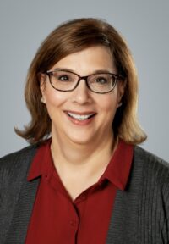
Angie serves as the Preschool/Children’s Consultant for Discipleship and Sunday School Ministries at the Mississippi Baptist Convention Board. Before joining the MBCB, she served as a Children’s Minister in several Mississippi churches. She has a passion for developing leaders and seeing churches catch a vision for vibrant Children’s Ministry.

Maintaining Church Membership Rolls – John Pace


John Pace has been serving as the Director Leadership for the Mississippi Baptist Convention Board (MBCB) since 2018. Prior to his service at the MBCB, he served as pastor of FBC Terry for 20 years and as pastor of Walnut Grove Baptist Church for 5 years. Since coming to the MBCB, John has served as Interim Pastor of numerous churches across Mississippi. John earned his Master of Divinity (1991), Master of Theology (2002), and Doctor of Philosophy (2007) from New Orleans Baptist Theological Seminary (NOBTS), and has served both as adjunct professor and as the
Jackson, MS Extension Center Director for NOBTS.

Unlocking Volunteer Potential in Your Church – Dwayne Parker

Dwayne Parker serves as the Director of Discipleship and Sunday School for the Mississippi Baptist Convention Board (MBCB). With extensive ministry experience, he has held roles as both Interim Pastor and Interim Discipleship Pastor. Prior to his work with the convention, Dwayne dedicated 27 years to ministry at First Baptist Church of Flora, Mississippi. In 2019, he earned a Doctor of Ministry degree from Southeastern Baptist Theological Seminary, further equipping him for impactful leadership and service.

Verse Mapping – Sunday Holmes
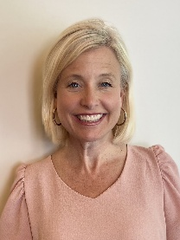
Sunday Holmes is a native of Brookhaven, MS. She is married to Jason Holmes, who currently serves on staff at First Baptist Church, Madison, MS. For over 25 years, they have served together in several churches across Mississippi and Tennessee with student and family ministries. Together they have 3 children - JM and Sarah Sunday who attend Mississippi College and Josh who is in 10th grade. Though she has held various jobs in education including teaching math and music, she considers those just her “tent making”. Her real love in life is to study and teach the Bible and serve her local church in any way God opens the door!

Events - Hints and Helps – Sandi Komurke
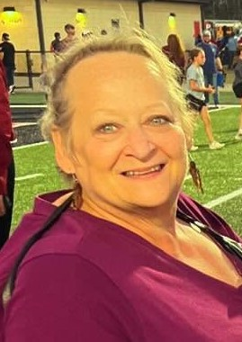
Sandi Komurke started at FBC Madison as the financial Ministry Assistant in 1992. She transitioned to the Education Ministry Assistant in 2018. In that time, God has opened doors to give her the fun experience of directing weddings, events and teaching different arts and crafts projects which helped her learn a bit about how to plan, set up and organize events that go on in the church. She also enjoys sharing what she has learned with others to help them through their ministry.

Social Media Strategies for Churches – Lorie Hanson


Lorie is the Director of Communication at First Baptist Church Madison, where she oversees the design of all visuals, manages social media, and brings events to life through creative marketing. Lorie is also a guest speaker at the 2025 Mississippi Worship and Media Conference, sharing her expertise in communication and creative ministry.

Optional Events

Door Prize
Join in the “fun”!
If you bring a door prize ($20.00 or less in value) you’re guaranteed to receive a door prize – AND: Your name will be entered into the Grand Prize drawing!

Mission Project
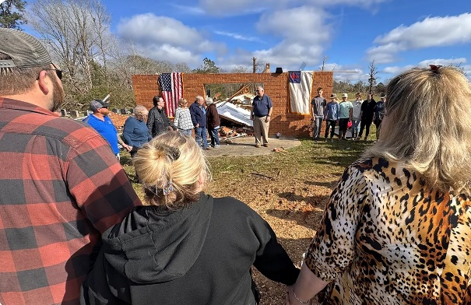
Each year we choose a mission project for the conference. This year we will be contributing toward the rebuilding efforts of O’Zion Baptist Church in Meadville, MS. On Saturday, December 28, 2024, a tornado completely destroyed the church. An article about the storm and the miraculous safety of two individuals who were in the church at the time can be found at https://thebaptistrecord.org/little-church-big-heart-tornado-survival-brings-renewed-faith/
If you choose to participate, there will be a designated box for you to contribute your monetary donations (cash or checks).

Silent Auction
- God has blessed us with so many talented Ministry Assistants and we utilize the Silent Auction to showcase those talents.
- Individuals can participate by bringing and/or bidding on the items.
- Items should be handmade & non-perishable. (Handmade gifts are not only cherished, but they also add something special to the auction by showing off your very own talent.)
- The items will be displayed with bid sheets beside them, so please have a starting value in mind for your item.
At the end of the conference, winning bids for each item will be announced and those individuals can make payment to the MBMAA Treasurer.
Please remember to bring your cash/checks to pay for your winning bids.

