**SBC Workspace overview for Associational Staff (2025)**

Log into your account using your SBC Workspace Credentials at [www.sbcworkspace.com](http://www.sbcworkspace.com).

This will give you access to ALL the churches in your association.

No Open Surveys – The association does NOT complete an ACP (Annual Church Profile) thus you have no Open Surveys

**Click your organization name in blue located in the middle of your screen**

We will work through each of these tabs under your association names as we work through this packet.

For now, we will focus on the General Information tab which will appear when you first click into your association.

Check all the cells in white for your association. **Make sure the information is correct**. This organizational page will look/be formatted the same for each of your churches with their information as well.

The address boxes at the bottom of the page are very important for you and your churches.

**Tabs:**

* **General** – please check the information for your association and your churches
  + Mailing & Physical – only one if this is a preferred mailing address
* **Attributes** – nothing
* **Leaders –** this is for your Associational leaders
* **Affiliations**
* You can get to your churches and add data here.  No need to open each church via their UN and PW
* If you have a “missing” church could be a 990 “At Large” church – we will need documentation to move them under your association
* **Subscriptions** – nothing
* **Notes** – use to document information regarding churches
  + **NOT** for confidential information – do not use private notes
  + Churches **cannot** view notes - for association, MBCB and Lifeway (as gatekeeper to SBC leadership) viewing only

EXAMPLES:

* + some associations add a note when they enter or correct survey information for a church
  + church is in the process of closing/disbanding
  + church has a new phone number, note the old phone number belonged to previous pastor – include the old number for reference
* **Statistics** – This option is no longer available at the association level. Please check in Reports tab for statistical reports/information
* **Reports** - please look at this tab and the many options available to you – you also have access to the reports for your churches via their Reports tab

**ASSOCIATION LEVEL REPORTS**

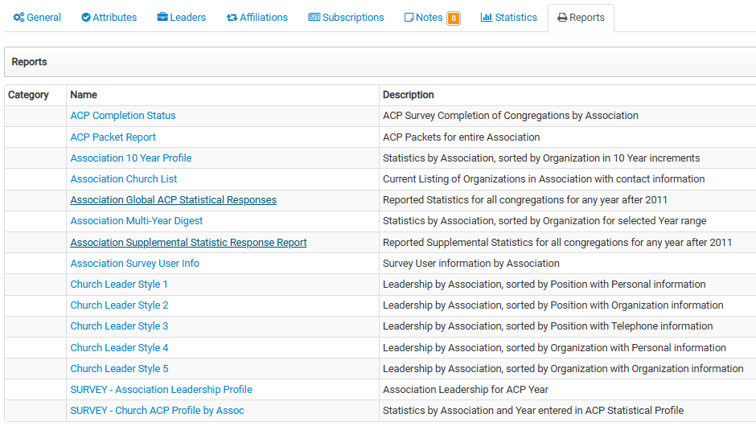

* **Association 10 year Profile** - this report has not been available for several years but is available to you again. Shows the “trends” for your association over a 10-year period.
* **Association Multi-year Digest** – Statistical information for individual churches in a given year or timeframe.
* **Association Survey User Info** – print this report for yourself TODAY. You will see each of your churches with their Username (which is their SBC ID) / Username. When a church calls and has lost this information, you can share it with them quickly.

**CHURCH LEVEL REPORTS**

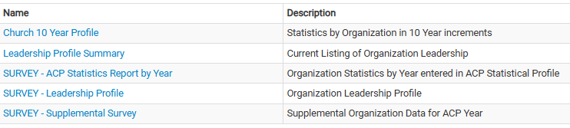

**ACP Packets**

**Please remind your churches that the ACP Packet has Three Parts this year** – this information is covered in 2025 ACP Overview for Churches Handout

1. General / Organization

2. 2025 ACP Statistical Profile (includes the MS Supplemental Questions)

3. Leadership Profile

MBCB will:

1. Provide mailers to use for sending/passing out the ACP to your churches.
2. Will be sending a note to go with the ACP Packet with information about changes to the 2025 ACP and info about new positions.

We ask that the Association include a letter from the association when the packet to mailed/given/emailed to the church. Please include the following:

* Time frame you are suggesting that they use
* Emphasize the Due Date
* Who should they contact should they have questions?

­­­­­­­­­­­­­­­­­­­­­­­**How to download packets from SBC Workspace**

1. Open SBC Workspace for your association
2. Make sure on the “General” Information page that the correct address for the churches to return their ACPs is the “Preferred Mailing Address” at the bottom of the page
3. Go to the REPORTS tab
4. Click on “ACP Packet Reports”
5. Enter the year – 2025
6. Enter the Due Date – the date by which you want your churches to return the date to you.
7. Hit the “Print/Download” button and the reports will be downloaded.
8. Check the bottom of the first page to verify that the DUE DATE and RETURN TO: address are both correct.
9. Then print the reports.

*\*\*Suggestion – this report goes to your “downloads” folder and is called “long form for association”. I suggest that you save that report so you will have a quick copy should one of your churches need an additional copy.*

**How to save ONE ACP report form the ACP Packet Reports from your association:**

1. Open your complete list of ACP Packet Reports for your association mentioned above.
2. Use the magnifying glass on the toolbar.
3. Type in the organization/church for which you are looking.
4. Find out which pages the report you need to include.  (Page numbers are at the center, top of the page. Find the packets first page number and page down to its last page number.)
5. Hit the Print Icon at the left side of the Toolbar along the top of the page.
6. At the top of that block, it says: Printer (This is the location to which you will print the report.)
7. DO NOT USE your default printer!
8. Look at the dropdown list of Printer options and one will be “Microsoft printer to PDF”.  Click on that option.
9. Under “Pages to Print” choose “Pages” and put it in your page range.  (Found in #4 above).
10. Then hit the print button and a save option will appear, the document will not print on your printer.
11. Save the document in the folder of your choosing and you are ready to attach it to an email.

This same process is used to print a report for ONE church. Disregard step #7 and in step #8 – USE your default printer as the option you take.

You will still need to complete steps 9 & 10. In step 10, the report will be printed via your default printer.

**­­­­­­­­­­­­­­­­­­­­­**

**How to Enter ACP Data for Your Churches**

There are several different ways to enter data for your churches. Find one that works well for you and stick with it. You DO NOT need to log in to each individual church to enter their data. You can enter data for your churches via your association in Workspace.

**Option #1 for Entering Data for your churches**

1. On your associations home page, Click Organization on the top toolbar.
2. Then click on “search”.

1. In the organization search box, type the church SBC ID # and click the blue Search button.
2. Click the red grid to the left of the blue hyperlink of the church name.

1. Survey appears for the default year of 2025.

1. Click on the “open” survey to start entering data.

**Option #2 for Entering Data for your churches**

1. Click the Survey tab in the upper left-hand corner of your screen.
2. Then click “search”. ***Should be 2025 in the box***

1. In the survey search box, type the church name or SBC ID#. Check that the current year is listed and that all 5 statuses are checked in the drop-down box. (You can save these filters.)
2. Click the blue search button.
3. Survey will appear. Click on survey to continue.

**REMINDER: When entering ACP Data for your churches**:

**Don’t forget to click the Save button presented at the end of each Survey.**

Note: When you click Save, you will be presented with this question (make sure you click the correct response).  If you click “Yes”, you will not be able to make any further changes to that profile.  If you click No, it will save your entries but allows you to make changes later if needed.

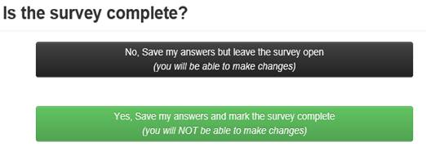

Should you find an item that needs corrected after a report is marked “complete”, please contact Vesta Clary at 601-292-3310 or [vclary@mbcb.org](mailto:vclary@mbcb.org). Vesta will either open the report for you again or she can update the information for you.

**Tabs at the top left of the screen**

* **WS** – gets you back to the home screen (magic button)
* **People** - search for people

Should you find a person with multiple records, please contact Vesta and ask her to merge the reports together.

* **Organizations** - search for an individual church or association
* **Surveys**
  + **Search** – Where to go when adding ACP data for one of your churches. Make sure to select the current year in the drop down.
  + **Survey Reports** – Quick link to all the available reports available to the association.
* **Data Query –** pulling various lists for your association